|  |  |  |  |  |  |  |  |
| --- | --- | --- | --- | --- | --- | --- | --- |
| **System:** | DRAGONFLY | | | **Sub-Subsystem:** | | Battery | |
| **Flight/Increment Applicability:** | | | | **Mission Phases:** | | | |
| HTV-X / Cygnus / Dragon  Inc, (TBD) and subsequent stages. | | | | **Launch Processing:** **Launch:** **Rendezvous / Docking:**  **Deployment:** **Orbital Assembly & Checkout:** **On-orbit Operation:**  **On-orbit Maintenance:** **Descent / Landing:** | | | |
| **Scope:** | | | | **Interfaces:** | | | |
| **Payload:** **JEM - PM:**  **JEM - EF:**  **Other( ):** | | | | **JEM-PM** **JEM-EF** **JEM-AIRLOCK** **JEMRMS**  **Other( ):** | | | |
| **Hazardous Condition Description:** | | | | | | | |
| Leakage of electrolyte or rupture of battery will potentially lead to contamination, corrosion, injury to ISS crew, or damage to other equipment on ISS.  Note. CubeSat uses Ni-MH battery cells.  Refer to Appendix G-2, BIRDS-X Battery Description Form (Ni-MH, Panasonic, BK-3MCC, configuration 3S2P) | | | | | | | |
| **Cause Summary:** | | | | | | | |
| Cause 1. Battery Failure of the CubeSat | | | | | | | |
| **Remarks:** | |  | | | | | |
| **Submittal Concurrence:** | | | | | **Safety Review Panel Approval** | | |
| **Signature** | | | **Date** | | **Signature** | | **Date** |

|  |  |  |
| --- | --- | --- |
| **Cause Number:** | **Cause Title:** | |
| 1 | Battery Failure of the CubeSat | |
| **Hazard Cause Description:** | | |
| 1.1 Battery cell internal short  1.2 Cell/battery external short  1.3 Overcharging of battery  1.4 Over-discharging of battery  1.5 Thermal Extremes | | |
| **Severity:** | | **Likelihood:** |
| **I (Catastrophic)** **II (Critical)** | | **A (Probable)** **B (Infrequent)** **C (Remote)** **D (Improbable)** |
| **Controls:** | | **Verification Method and Status:** |
| 1.1. Screening by environment test such as vibration and vacuum tests are performed to check that there is no defect in the battery cells (Refer to Figure 3).  1.2-1. Battery pack is designed / assembled with appropriate electrical isolation between each cell and wiring (Refer to Figure 4).  1.2-2. Protection devices for short circuit are equipped to protect from external short. The protection devices are SepSW2, SepSW3, DCDC convertor and Isolation (Refer to Figure 1 and Figure 5).  1.3. Protection devices are equipped to protect from overcharging.  The protection devices are SepSW1, SepSW2 and DCDC converter. (Refer to Figure 1).  Note: The battery cells would not be charged even if a fluorescent light shines on the solar cells while on ISS.  1.4-1. Protection device is equipped to protect from over-discharging.  The protection devices are DepSW2, SepSW2, SepSW3, SepSW4, DCDC convertor, Diodes and Isolation. (Refer to Figure 1 and Figure 5).  1.4-2. Proper charge the battery at the time of delivery as a measure against leakage current from signal lines.  1.5. Battery cells which meet the thermal environment condition defined in JX-ESPC-101132E, JPAH Vol.8 Small Satellite Deployment ICD, are selected. | | 1.1(1). Perform random vibration test at MSL (Minimum Screening Level) for each battery cells.  [Status] Open: BIRDSX-BVR-01, BIRDS-X Battery verification report (To be closed at Phase3)  1.1(2). Perform vacuum leak test (less than 0.1[psia] for longer than 6 hours) for each battery cells.  [Status] Open: BIRDSX-BVR-01, BIRDS-X Battery verification report (To be closed at Phase3)  1.1(3). Confirm there is no change in charge/discharge characteristics before and after the environmental tests.  [Status] Open: BIRDSX-BVR-01, BIRDS-X Battery verification report (To be closed at Phase3)  1.1(4). Perform the trend measurement of the open circuit voltage of the total  battery, after the environment test of the satellite system.  [Status] Open: BIRDSX-BVR-01, BIRDS-X Battery verification report (To be closed at Phase3)  1.2-1. Inspection of flight hardware to ensure there is appropriate electrical isolation between each cell and wiring.  [Status] Open: BIRDSX-IFTR-01, BIRDS-X Inhibit Function Test Report (To be closed at Phase3)  1.2-2(1). Confirm the protective design to prevent external short for the battery.  [Status] Closed: BIRDSX-EP-01, BIRDS-X Battery Description Form  (2024/01/29)  1.2-2(2). Perform short circuit protection function test.  [Status] Open: BIRDSX-IFTR-01, BIRDS-X Inhibit Function Test Report (To be closed at Phase3)  1.2-2(3). Confirm the battery monitor terminals are covered with Kapton tape  [Status] Close to VTL: 17_BIRDSX-VTL-01  1.3(1). Confirm the protective design to prevent overcharging for the battery.  [Status] Closed: BIRDSX-EP-01, BIRDS-X Battery Description Form  (2024/01/29)  1.3(2). Perform overcharging protection function test.  [Status] Open: BIRDSX-IFTR-01, BIRDS-X Inhibit Function Test Report (To be closed at Phase3)  1.4-1(1). Confirm the protective design to prevent over-discharging for the battery.  [Status] Closed: BIRDSX-EP-01, BIRDS-X Battery Description Form  (2024/01/29)  1.4-1(2). Perform over-discharging protection function test.  [Status] Open: BIRDSX-IFTR-01, BIRDSX- Inhibit Function Test Report (To be closed at Phase3)  1.4-2(1). Evaluate the leakage current of signal lines.  [Status] Closed: BIRDSX-SAR-01 Appendix C-10 Leakage current evaluation (2024/01/29)  1.4-2(2). Confirm that the battery voltage is in a state of final charge (SOC > 80%) at the time of delivery.  [Status] Close to VTL: BIRDSX-VTL-01  1.5-1. Perform thermal vacuum test covering the J-SSOD thermal environment condition for the battery cells from same lot with the flight cells.  [Status] Open: BIRDSX-BVR-01, BIRDS-X Battery verification report (To be closed at Phase3) |
| **Safety Requirements:** | | |
| SSP51721, ISS Safety Requirements Document | | |
| **Detection and Warning Methods:** | | **Additional Safety Features:** |
| － | | － |
| **Cause Remarks:** | | |
| － | | |
| **Mission Phases:** | | **Point of Contact** |
| **Launch Processing:** **Launch:** **Rendezvous / Docking:**  **Deployment:** **Orbital Assembly & Checkout:** **On-orbit Operation:**  **On-orbit Maintenance:** **Descent / Landing:** | |  |

**Attachment BIRDSX-UNQ-02, Battery Description (1/5)**

Normal electricity consumption is ~1W on orbit. BIRDS-X does not use the wet Electrolytic Capacitors in EPS.

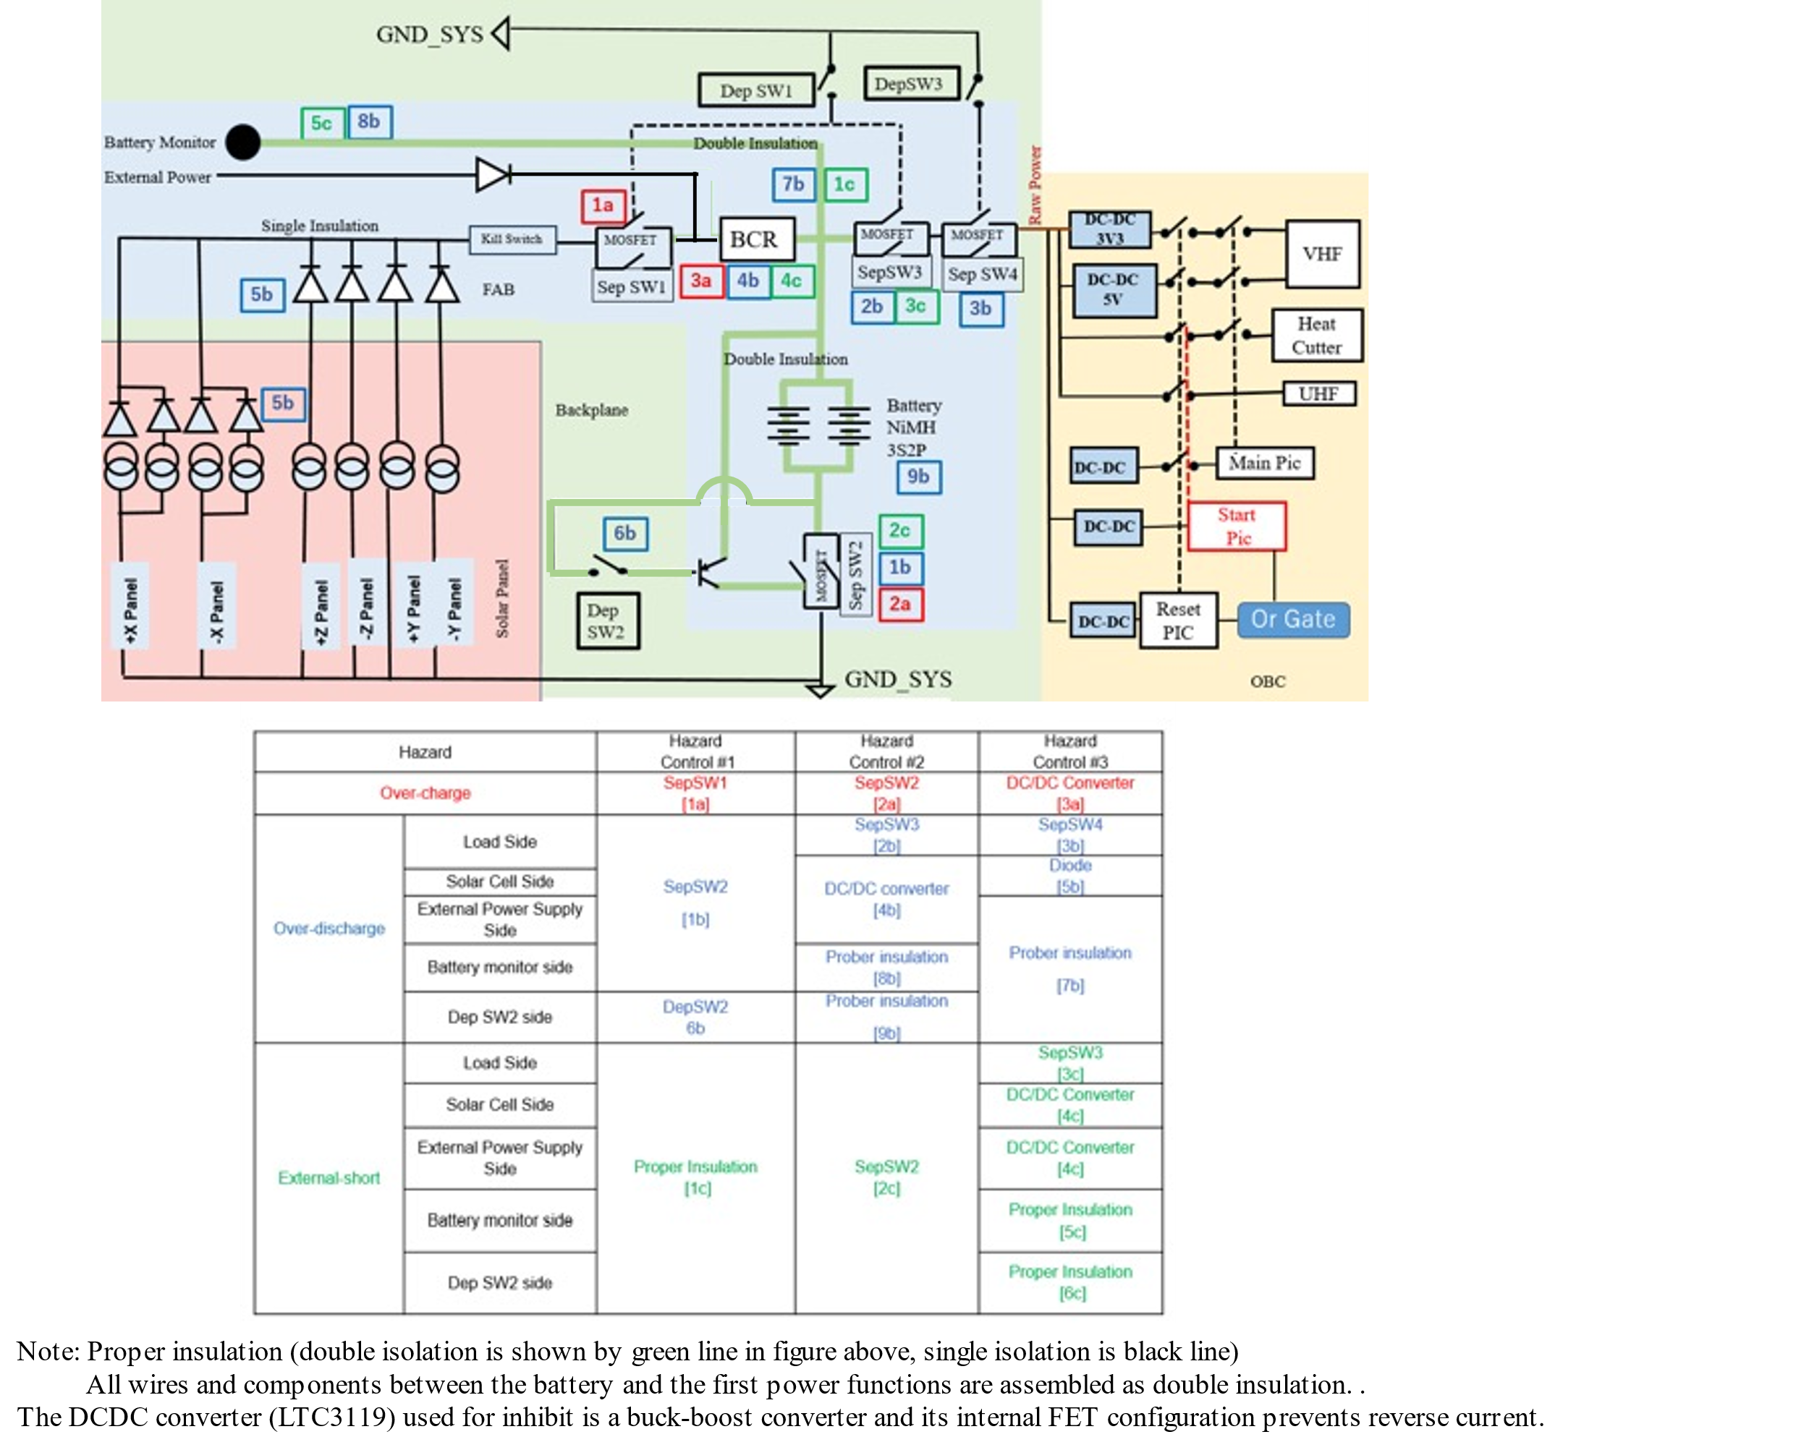

**Figure 1. Electrical Power Schematic**

**Attachment BIRDSX-UNQ-02, Battery Description (2/5)**

 

**Figure 2. DCDC convertor Schematic**

The DCDCC converter used is the LTC3119. As shown in the figure, pins 19 and 20 are the input from the solar cell and pins 3 and 4 are the output to the battery.

A step-up/down inductor is connected to pins 2,5 and 18,21.

This DCDC converter uses a PWM module to monitor the input voltage and switch the operating mode to buck or boost mode when the input voltage is higher, equal to, or lower than the output voltage by switching four switches, respectively.

**Attachment BIRDSX-UNQ-02, Battery Description (3/5)**



**Function Test**

* Visual inspection (scratches, misaligned seals, electrolyte leakage etc.)
* Open Circuit Voltage (the change is less than 0.1%)
* Mass (the change is less than 0.1%)
* Capacity (the change is less than 5%)
* Charge/Discharge Characteristic
* Discharge Temperature

**Figure 3. Flowchart for screening test**

**Attachment BIRDSX-UNQ-02, Battery Description (4/5)**

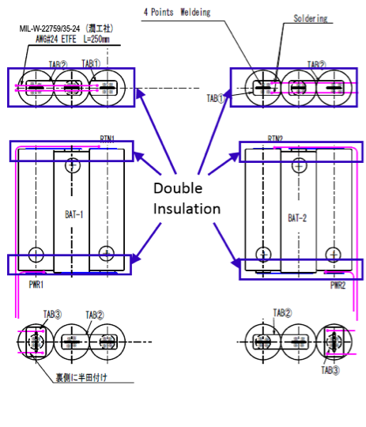

**Figure 4. Battery Connectivity**

**Attachment BIRDSX-UNQ-02, Battery Description (5/5)**



**Figure 5. RTV Potting position**